Teacher Notes for “Photosynthesis and Cellular Respiration
– Understanding the Basics of Bioenergetics and Biosynthesis”

In this minds-on activity, students analyze how photosynthesis, cellular respiration, and the hydrolysis of ATP provide energy for biological processes in plant cells. Students learn that the glucose molecules produced by photosynthesis are used for cellular respiration and for the synthesis of other organic molecules. The final section challenges students to use their understanding of photosynthesis and cellular respiration to explain observed changes in biomass for plants growing in the light vs. dark. These Teacher Notes suggest three possible additions to this learning activity.

Before your students begin this activity, they should have a basic understanding of photosynthesis and cellular respiration. For this purpose, I recommend the analysis and
discussion activities:
- How do organisms use energy? (https://serendipstudio.org/exchange/bioactivities/energy)
- Using Models to Understand Cellular Respiration
(https://serendipstudio.org/exchange/bioactivities/modelCR)
- Using Models to Understand Photosynthesis (https://serendipstudio.org/exchange/bioactivities/modelphoto)

A possible alternative hands-on activity that covers much of the same material is “Photosynthesis, Cellular Respiration and Plant Growth” (https://serendipstudio.org/sci_edu/waldron/#photobiomass). This hands-on activity begins with the question of how a tiny seed grows into a giant Sequoia tree. To answer this question, students analyze data from research studies on plant biomass, and they conduct a hands-on experiment to evaluate changes in CO₂ concentration in the air around plants in the light vs. dark. Students interpret the data to understand how photosynthesis makes an essential contribution to increases in plant biomass, and cellular respiration can result in decreases in biomass.

Table of Contents
Learning Goals – pages 1-2
Instructional Suggestions and Background Information
General – pages 2-3
First Two Pages of Student Handout – pages 3-6
Plant Growth Puzzle – pages 6-8
Additional Information – page 8
Optional Additions to this Activity
Storyboards – pages 9-11
Chemical Equations for Photosynthesis and Cellular Respiration – pages 12-14
Diurnal Variation of Starch in Leaves – page 15

Learning Goals
In accord with the Next Generation Science Standards:
- Students learn the following Disciplinary Core Ideas:
- LS1.C: "The process of photosynthesis converts light energy to stored chemical energy by converting carbon dioxide plus water into sugars plus released oxygen. The sugar molecules thus formed contain carbon, hydrogen, and oxygen; their hydrocarbon backbones are used to make amino acids and other carbon-based molecules… Cellular respiration is a chemical process whereby the bonds of food molecules and oxygen molecules are broken”, carbon dioxide and water are formed, and the energy released is used in the production of ATP from ADP and P. Then, the hydrolysis of ATP molecules provides the energy needed for many biological processes.
- Students engage in recommended Scientific Practices, including
  - “Constructing Explanations: Apply scientific ideas, principles, and/or evidence to provide an explanation of phenomena…”
  - “Developing and Using Models: Develop, revise, and/or use a model based on evidence to illustrate and/or predict the relationships between systems or between components of the system.”
- This activity can be used to illustrate the Crosscutting Concepts:
  - “Energy and matter: Flows, Cycles and Conservation” – “matter is conserved because atoms are conserved in physical and chemical processes… Energy may take different forms…”
  - “Cause and Effect: Mechanism and Prediction” – Students “suggest cause and effect relationships to explain and predict behaviors in complex natural and designed systems”.
- This activity helps students to prepare for Performance Expectations:
- HS-LS1-5, "Use a model to illustrate how photosynthesis transforms light energy into stored chemical energy."
- HS-LS1-7, "Use a model to illustrate that cellular respiration is a chemical process whereby the bonds of food molecules and oxygen molecules are broken and the bonds in new compounds are formed resulting in a net transfer of energy."
- HS-LS2-5, "Develop a model to illustrate the role of photosynthesis and cellular respiration in the cycling of carbon among the biosphere, atmosphere…”

This learning activity will help to counteract two common misconceptions (https://www.learner.org/vod/vod_window.html?pid=77; Hard-to-Teach Biology Concepts, page 135, by Susan Koba with Ann Tweed).
– Many students believe that only animals carry out cellular respiration and plants only carry out photosynthesis. They do not understand that plants also need to carry out cellular respiration to provide ATP for cellular processes.
– Many students don’t understand the importance of photosynthesis and find it hard to believe that the biomass of plants comes largely from a gas (CO₂).

Instructional Suggestions and Background Information
General
To maximize student participation and learning, I suggest that you have your students work in pairs (or individually or in small groups) to complete groups of related questions and then have a class discussion after each group of related questions. In each discussion, you can probe student thinking and help them to develop a sound understanding of the concepts and information covered before moving on to the next group of related questions.

If your students are learning online, we recommend that they use the Google Doc version of the Student Handout available at https://serendipstudio.org/exchange/bioactivities/photocellrespir. To answer questions 2-4, students can either print the relevant pages, draw on them and send you pictures, or they will need to know how to modify a drawing online. To answer online, they can double-click on the relevant drawing in the Google Doc to open a drawing window. Then, they can use the editing tools to answer the questions. If you are using the Word version of the Student Handout to make revisions, please check the PDF version to make sure that all figures and formatting are displayed properly in the Word version on your computer.

A key for the Student Handout and two of the optional additions (the storyboards and chemical equations) is available upon request to Ingrid Waldron (iwaldron@upenn.edu). The following paragraphs provide additional instructional suggestions and background information.

First Two Pages of Student Handout
The figure on the top of page 1 of the Student Handout follows the common practice of showing glucose as the sugar produced by photosynthesis. Photosynthesis directly produces a three-carbon molecule, glyceraldehyde-3-phosphate, which plant cells use to synthesize glucose and fructose. Some of the glucose and fructose are used to make sucrose which is transported to other parts of the plant.

As you know, hydrolysis refers to a chemical reaction in which a molecule is split into smaller molecules by reacting with water. Students may be less familiar with this term and may need help to recall this definition. This figure shows the hydrolysis of ATP.

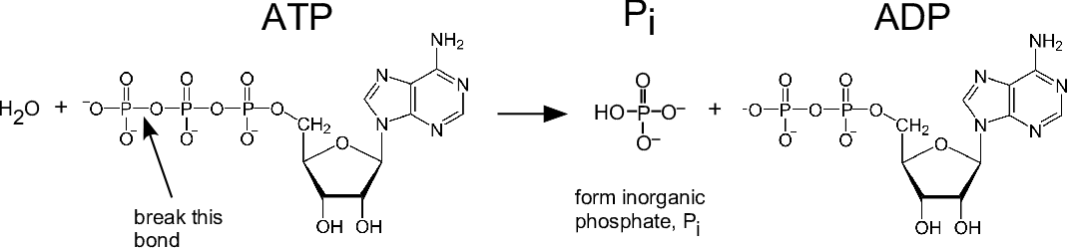

A small amount of energy is required to cleave the terminal phosphate from ATP, but more energy is released when this phosphate combines with water to form the hydrogen phosphate ion (HPO₄–). This is often referred to as simply phosphate (abbreviated as P or P_{i}). (The figure omits the H⁺ ion which is produced by the dissociation of the weak acid H₂PO₄– H⁺ + HPO₄–.)

The Student Handout does not mention that the hydrolysis of ATP usually occurs after the ATP has bound with a substrate molecule, e.g. a motor protein or one of the reactants in a synthesis reaction. In this way, the exergonic hydrolysis of ATP is coupled with the endergonic change in conformation of the motor protein or the synthesis reaction.

Question 1 helps students to understand several important points:
- Cells can not directly use sunlight or glucose to provide the energy for most biological processes. Therefore, all organisms (including plants) need to make ATP which can provide energy in the form needed to carry out many cellular processes (e.g. pumping substances into and out of cells and synthesis of organic molecules).
- Most organisms, including plants, carry out cellular respiration to produce ATP.
- All organisms need a source of organic molecules for cellular respiration, but plants use photosynthesis to make organic molecules, whereas animals eat food to get organic molecules.

In your discussion of energy, you should be aware that, although it is common to describe chemical energy as stored in glucose, it is more accurate to describe chemical energy as a property of the system of glucose and O₂ which interact to produce CO₂ and H₂O. This point is illustrated by the contrast between the larger amount of ATP produced by aerobic cellular respiration of glucose vs. the much smaller amount of ATP produced by anaerobic fermentation of glucose in the absence of O₂ (see “How do muscles get the energy they need for athletic activity?” https://serendipstudio.org/exchange/bioactivities/energyathlete). In discussing cellular respiration and hydrolysis of ATP, it is important to remember that breaking bonds always requires energy input and energy is released only when new more stable bonds are formed. Expanded explanations of these points are provided in “Cellular Respiration and Photosynthesis – Important Concepts, Common Misconceptions, and Learning Activities” (https://serendipstudio.org/exchange/bioactivities/cellrespiration).

Page 2 of the Student Handout introduces the concept that the glucose molecules produced by photosynthesis are used not only for cellular respiration, but also for the synthesis of other organic molecules in plants. (Organic molecules are complex, carbon-containing molecules found in living organisms.) The figure below provides some additional information about how glucose is used to synthesize a variety of organic molecules.
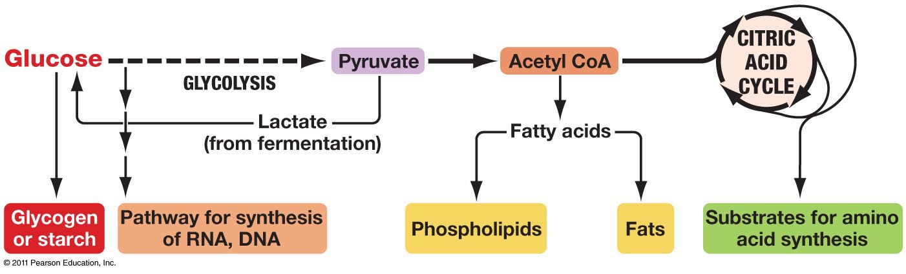
(http://www.uic.edu/classes/bios/bios100/lectures/09_28_anabolic_pathways-L.jpg )

A plant needs nitrogen and phosphorus from soil water in order to synthesize amino acids, nucleotides, and phospholipids. The figure below illustrates this generalization for amino acids.
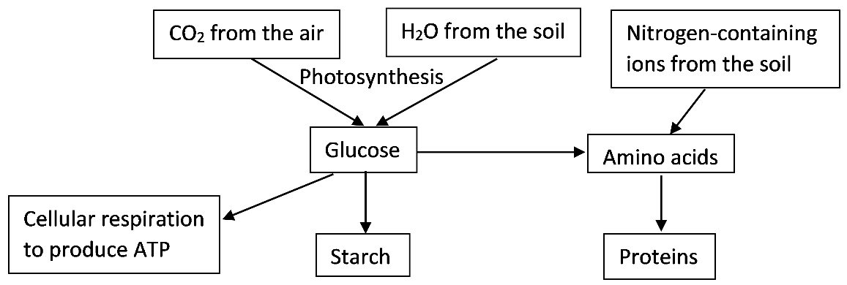

The second figure on page 2 in the Student Handout shows that glucose monomers are joined in different ways in cellulose and starch polymers. This difference in how the glucose monomers are linked results in different shapes for these polymers. Starch molecules have a helical or branched form. In contrast, cellulose molecules are straight and cross-linked by hydrogen bonds to form microfibrils that give strength to plant cell walls. Animals can digest starch, but not cellulose (although the guts of ruminants and termites contain microorganisms that can digest cellulose).

The figure below provides some additional information about starch synthesis. Notice that:
- The synthesis of starch requires ATP; this is an example of how ATP provides energy for the processes of life.
- The synthesis of starch requires enzymes.
- Glucose monomers are added one at a time to synthesize the starch molecule.
(These points are also relevant for the synthesis of other biological polymers.)

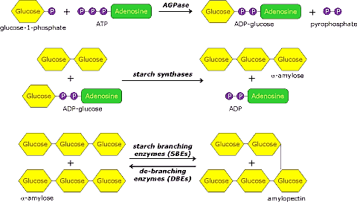
(http://www.andrewgray.com/essays/starchp.gif)

When you discuss question 7a, you may want to point out the similarities between the dual functions of sugar molecules produced by photosynthesis and the dual functions of food molecules for a person (as discussed in "Food, Energy and Body Weight", https://serendipstudio.org/exchange/bioactivities/foodenergy).

Starch synthesis is useful for storing glucose to be used for cellular respiration in future situations where photosynthesis cannot occur. For example, starch is stored:
- in seeds for use when seedlings first sprout
- in tubers for use in generating a plant after a cold or dry season
- in leaves during the day to provide glucose for cellular respiration during the night (see the last page of these Teacher Notes).

Plant Growth Puzzle
The first two pages of the Student Handout provide the background for students to analyze the plant growth puzzle. In this section, students are introduced to the concept of biomass and then apply their understanding of photosynthesis and cellular respiration to predict and then interpret changes in biomass for plants growing in light vs. dark.

Question 9 asks students to predict the change in biomass in each experimental condition and give a reason for each prediction. The goal is for each student or group of students to use what they know thus far to make a prediction that they can support with a reasonable, logical explanation. The next page of the Student Handout provides the opportunity to discuss the actual results and the reasons for these results.

After the students have completed question 9 you should inform your students of the results of the experiment.
 | Light, no water | Light, water | Water, no light
Biomass after 10 days | 1.46 g | 1.63 g | 1.20 g

The fact that there was no significant change in the biomass of the dry seeds reflects their dormant condition in which very little cellular respiration and no photosynthesis is occurring.

Question 11 asks students to explain the seeming discrepancy between the greater total mass of the plants in the “water, no light” condition vs. the greater biomass of the seeds in the “light, no water” condition. The plants in the “water, no light” condition lost biomass due to the effects of cellular respiration without photosynthesis. However, they gained water which resulted in greater total mass. Approximately 75% of the mass of actively growing plants is water.

This figure summarizes the basic processes involved in plant growth. The figure shows growth processes in a root; the same basic processes occur in a shoot (stem and leaves).  As shown, plant growth depends on cell division to form new cells plus the increase in size of individual cells (called elongation in the figure). Elongation involves synthesis of additional organic molecules and uptake of water. Cell division typically occurs at the tips of the root and the shoot, each of which has a meristem that has undifferentiated cells that divide repeatedly. | 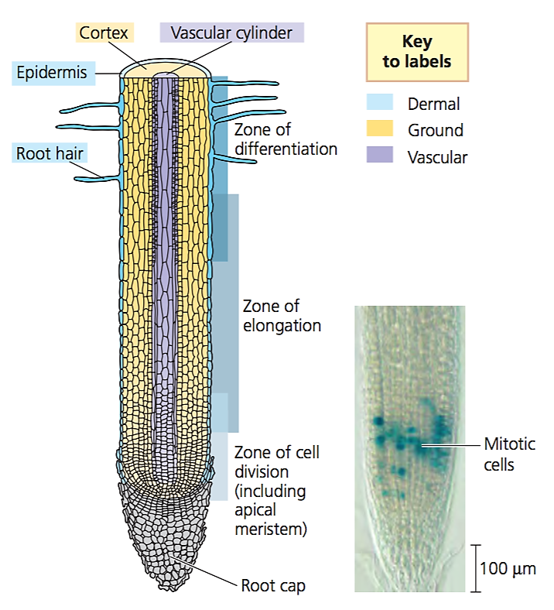  (https://apbiologyctd.files.wordpress.com/2015/07/screen-shot-2015-07-26-at-1-19-24-pm.png)

The figure below may help your students visualize how plants get the water and carbon dioxide needed for photosynthesis.

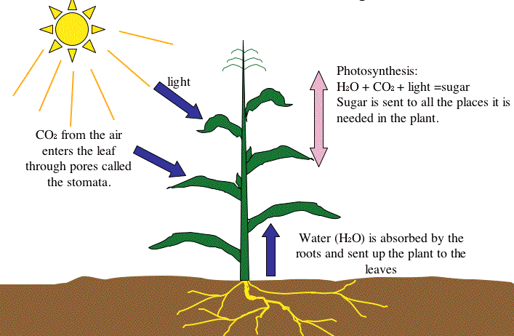
(http://3.bp.blogspot.com/_T1SM8UaQv64/TOLwGH5W38I/AAAAAAAAAFI/DC5qgqo3uBg/s1600/Slidephotosynthesis.gif)

The plants in the experiment described were grown in petri dishes with water, but no soil. This observation can be used to reinforce the important concept that most of a plant’s biomass comes from the air (CO₂) and relatively little from the minerals in the soil. For additional information and a learning activity, see "Where does a plant's mass come from?" (https://serendipstudio.org/exchange/bioactivities/plantmass). As discussed in that learning activity, some minerals would be required in order for growth to continue.

With regard to the Bonus Question, plants respond to light by producing more chloroplasts with more chlorophyll. The differences between plant development in the light and dark are controlled by complex molecular processes that involve phytochrome molecules that respond to light and plant hormones (e.g. auxin and giberellins) that control transcription factors.

Sources for figures in Student Handout
- page 1 and top of page 2 – modified from https://sites.google.com/site/lmwhitebiology/_/rsrc/1443747840357/energy/photosynthesis-cellular-respiration/photosynthesis%20and%20cellular%20respiration%20image%202.gif?height=400&width=368
- page 2, starch and cellulose – modified from https://classconnection.s3.amazonaws.com/954/flashcards/1172954/jpg/biopic1328807784092.jpg
- page 2, seedling growing underground – http://interpretapp.co/wp-content/uploads/2018/12/life-cycle-of-flowering-plants-lesson-plan-a-plant-worksheets-free-thunderbolt-kids-seed-dispersal-worksheet-grade-5-cycles-for-pdf-workshee.jpg
- pages 3-4 – From Ebert-May et al., Disciplinary Research Strategies for Assessment of Learning, BioScience 53:1221-8, 2003

Optional Additional Activities
Possible add-ons for this activity are given in the pages that follow.

Additional background and learning activities are provided in “Cellular Respiration and Photosynthesis – Important Concepts, Common Misconceptions, and Learning Activities” (http://serendipstudio.org/exchange/bioactivities/cellrespiration).

Storyboards

To help students understand the big picture and consolidate their understanding of photosynthesis and cellular respiration, you can use a modified version of storyboarding, as follows:
- Before students begin the Student Handout, students work in pairs and use their background knowledge to respond to the Introductory Photosynthesis and Cellular Respiration Storyboard (shown on page 10 of these Teacher Notes). This will help to activate students’ memory of relevant concepts and information. I recommend that you review these initial storyboards to learn more about your students’ knowledge and any misconceptions they may have. This storyboard is intended for formative assessment only.
- As students increase their understanding of photosynthesis and cellular respiration during the activity, they can modify their Introductory Storyboards.
- After completing the activity presented in the Student Handout, students complete the Follow-up Storyboard (shown on page 11 of these Teacher Notes) without looking at their earlier storyboard or the Student Handout. After they complete the Follow-up Storyboards, students should have prompt feedback so they can improve the accuracy and completeness of their storyboards; you can accomplish this in a class discussion where students compare their storyboards. This type of active recall with feedback helps to consolidate student understanding and retention of the concepts learned during the activity.

Introductory Photosynthesis and Cellular Respiration Storyboard

1. Draw lines to connect each molecule that is the same in the upper and lower figures in the left-
hand column.
2. For each figure on the left, write the name of the process in the rectangle.
3. Describe what is happening in each of the four figures shown. Use terms such as:
cellular respiration, photosynthesis, hydrolysis of ATP, carbon dioxide, glucose, oxygen, water, provides energy for many biological processes.
4. Note any questions you have.

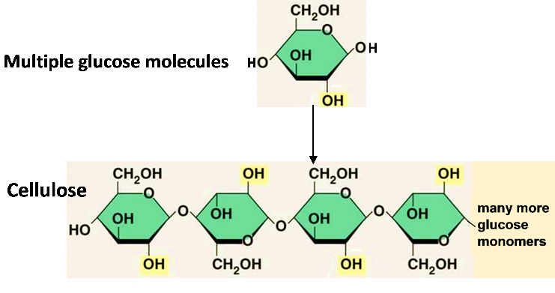

ADP + P
ATP + H₂O

Follow-up Photosynthesis and Cellular Respiration Storyboard

1. Fill in the blanks to show an overview of photosynthesis.

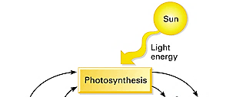

____________ ____________ ___________ ______________

2. Add to your diagram to show cellular respiration and how cellular respiration is related to photosynthesis.

3. Add to your diagram to show how ATP provides energy for many biological processes. Show how this reaction is related to cellular respiration.

4. Sometimes the rate of photosynthesis exceeds the rate of cellular respiration, so some of the glucose molecules produced by photosynthesis are not used for cellular respiration. Add to your diagram to show what happens to the glucose molecules that are produced by photosynthesis and are not used for cellular respiration.

Chemical Equations for Photosynthesis and Cellular Respiration

Both photosynthesis and cellular respiration consist of multiple chemical reactions which are summarized in the chemical equations the students will prepare to answer the questions on the next page. This page could be inserted after page 1 in the Student Handout.

If your students are familiar with the terms exergonic and endergonic (or exothermic and endothermic), you can substitute those terms for energy-releasing and energy-consuming in question 5c on the next page.

After discussing the questions on the next page, you may want to have your students compare and contrast the diagram of photosynthesis and cellular respiration that they have developed in their answers to these questions with the diagram shown in the figure on page 1 of the Student Handout.

Supplies
Each student or pair of students will need a piece of paper that they can tear or cut into 16 rectangles and label these rectangles as directed on the next page. If you prefer, you can print copies of page 14 of these Teacher Notes, cut each page in thirds, and have students write the names of the molecules in the first column and then cut out the rectangles.

Questions you can add after question 3 in the Student Handout

To represent the overall chemical equations for photosynthesis and cellular respiration, you will use 16 rectangles. Divide a sheet of paper into 16 rectangles.

For photosynthesis, prepare:
- four rectangles, each with one of the following: C₆H₁₂O₆, 6 CO₂, 6 H₂O, 6 O₂;
write the name of the molecule represented by each chemical formula
- two rectangles with +
- one rectangle with ––––→ to represent the chemical reactions of photosynthesis
- one rectangle with sunlight

For cellular respiration, you will need all of the photosynthesis rectangles except the last, plus:
- four rectangles, each with one of the following: ~29 ATP, ~29 ADP, ~29 P, ~29 H₂O
- two additional rectangles with +
- one rectangle with ––––→
- one rectangle with two curved arrows

4. Arrange the eight rectangles for photosynthesis to summarize the chemical reactions for photosynthesis. Copy this chemical equation into the top box in this chart.

Photosynthesis

Cellular Respiration

5a. To show cellular respiration, begin by rearranging the photosynthesis rectangles (except for sunlight) to summarize how glucose and oxygen react to form carbon dioxide and water.

5b. Beneath that, arrange the other rectangles (except for the curved arrows) to summarize how ATP is synthesized from ADP + P.

5c. Replace both straight arrows with the pair of curved arrows to indicate that these two sets of chemical reactions are coupled reactions, with energy transfer from the first energy-releasing reaction to the second energy-consuming reaction.

5d. Copy these chemical equations into the bottom box in the above chart.

6. Draw two dashed arrows to show how the products of photosynthesis can be used as the inputs for cellular respiration. Next, draw two dashed arrows to show how two of the products of cellular respiration can be used as the inputs for photosynthesis.
Pieces for Three Students or Pairs of Students for Page 13

C₆H₁₂O₆ | + | ~29 ATP | +
6 CO₂ | + | ~29 ADP | +
6 H₂O | ––––→ | ~29 P | ––––→
6 O₂ | sunlight | ~29 H₂O

C₆H₁₂O₆ | + | ~29 ATP | +
6 CO₂ | + | ~29 ADP | +
6 H₂O | ––––→ | ~29 P | ––––→
6 O₂ | sunlight | ~29 H₂O

C₆H₁₂O₆ | + | ~29 ATP | +
6 CO₂ | + | ~29 ADP | +
6 H₂O | ––––→ | ~29 P | ––––→
6 O₂ | sunlight | ~29 H₂O

Diurnal Variation of Starch in Leaves
The figure below shows the diurnal fluctuation of starch levels in leaves of coleus. During daylight hours, photosynthesis produces glucose, and some of the glucose is used to produce starch. During the night, starch is broken down to provide the glucose needed for cellular respiration. Therefore, starch levels in leaves tend to be highest at the end of daylight and lowest at the end of the night.
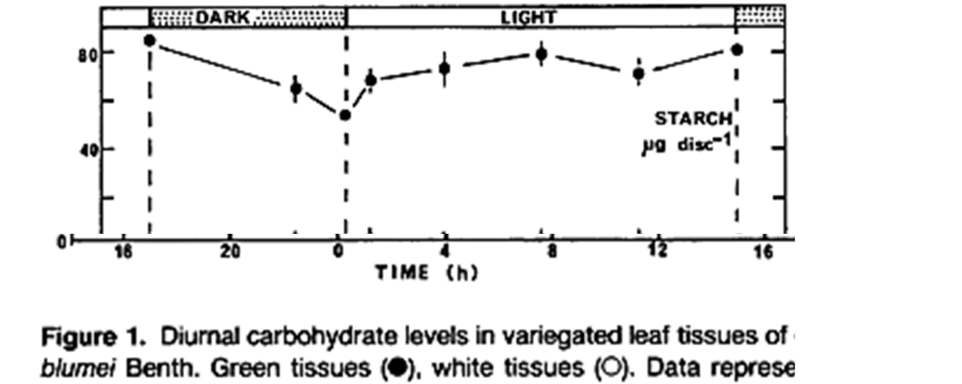

(Source: “Carbohydrate metabolism in photosynthetic and non-photosynthetic tissues a variegated leaves of Coleus blumei Benth.”
Plant Physiology (1990) 93:617-622.)

You may want to insert these questions after question 7 in the Student Handout or you may want to use these questions for summative assessment.

When photosynthesis produces more glucose than the plant needs, the excess glucose is stored in starch molecules. Starch molecules can be broken down to provide glucose when glucose is needed for cellular respiration.

8a. A plant needs to carry out cellular respiration throughout the day and night in order to produce the ATP which provides energy for the processes of life. In the reversible reaction below, write “night” to label the arrow which shows how the plant gets the glucose needed for cellular respiration at night.

multiple glucose molecules starch molecule

8b. Do you think that leaves have more starch molecules at the end of daylight or at the end of the night? Explain your reasoning.

9a. In the light, a growing plant takes in more CO₂ than it produces. Explain why. Where do the carbon atoms from the CO₂ go?

9b. In the dark, a plant produces more CO₂ than it takes in. Explain why.

By Dr. Ingrid Waldron, Department of Biology, University of Pennsylvania, 2019. These Teacher Notes and the related Student Handout are available at https://serendipstudio.org/exchange/bioactivities/photocellrespir.
Quotations are from http://www.nextgenscience.org/sites/default/files/HS%20LS%20topics%20combined%206.13.13.pdf
To draw a shape - At the top of the page, find and click Shape. - Choose the shape you want to use. - Click and drag on the canvas to draw your shape. To insert text - At the top of the page, click Insert. - To place text inside a box or confined area, click Text Box and drag it to where you want it. - Type your text. - You can select, resize and format the word art or text box, or apply styles like bold or italics to the text. When you are done, click Save and Close.
If you want to reinforce this concept, you could use this question: "Cells in plant leaves have both chloroplasts and mitochondria. If plant cells can carry out photosynthesis to produce sugars, why do plant cells need mitochondria?" The important point that plants need to carry out cellular respiration contrasts with some diagrams of the carbon cycle in ecology which show photosynthesis occurring in plants and erroneously show cellular respiration occurring only in animals. The present activity provides a useful preparation for understanding carbon cycles. To help your students learn about carbon cycles, I recommend "Food Webs, Energy Flow, Carbon Cycle, and Trophic Pyramids" (https://serendipstudio.org/sci_edu/waldron/#ecolfoodweb) or "Carbon Cycles and Energy Flow through Ecosystems and the Biosphere (https://serendipstudio.org/exchange/bioactivities/carboncycle).
This figure shows starch synthesis in amyloplasts. In chloroplasts, starch synthesis begins with a different first step (http://www.uky.edu/~dhild/biochem/10/lect10.html).
A hands-on activity which develops the same concepts is presented in "An Inquiry-based Approach to Teaching – Photosynthesis and Cellular Respiration" by Dan O'Connell, American Biology Teacher 70(6): 350-6, 2008.
These data are from Ebert-May et al. (2003) Bioscience 53:1221-8.
This general approach is described in "Using Storyboarding to Model Gene Expression", American Biology Teacher 77:452-457, 2015.
Evidence for the benefits of active recall with prompt feedback is described in http://www.scientificamerican.com/article/researchers-find-that-frequent-tests-can-boost-learning/.
I thank Brianna Chang for suggesting this add-on activity.

